1. **Auralization**
   1. **Room Impulse Response Synthesis**

Impulse responses, suitable for signal processing and particularly for auralization, must have a sampling rate appropriate for the audio frequency range, typically about $44kHz$. Thus, image source algorithms, ray tracing techniques or hybrid models are commonly in practice and are equally applicable. The impulse responses are inputs of an FIR filters for convolution with dry source signals. These impulse responses can be constructed monaural as well as binaurally. However, room auralization must be based on binaural hearing, otherwise the spatial information would be lost [**1**]. We learnt from the previous chapters about Geometric Acoustics (GA), where two commonly used methods for room acoustics were discussed (i.e. Image Source Method (ISM) and Ray Tracing (RT) Method). In this chapter, we discuss the room impulse response synthesis.

* + 1. **Image Source Method**

Constructing a room impulse response (RIR) from audible image sources (ISs) is rather simple. Each reflection initially shows up as a Dirac delta function, which is delayed by the travel time and attenuated by both the wall absorption on each reflection and the absorption by air according to the travel distance, shown in Figure **4.1**. Additionally, if the sender or the receiver features a non-negligible directional pattern, this information has to be added to the RIR.

|  |
| --- |
|  |
| **Figure 4.1:** Construction of RIR (time domain) [**3**] |

|  |  |
| --- | --- |
|  | **(4.1)** |

Here, $H_{j}$ denotes the spectrum of the $j^{th}$ reflection path, i.e. an audible IS, $t_{j}$ is the delay time with phase shift $jωtj$, $\frac{1}{ctj}$ the distance law for spherical waves, $H_{Source}$ the directional pattern of the source, $H_{Receiver}$ the directional pattern of the receiver, $H_{air}$ is air attenuation and $R_{i}$ the reflection factors of the walls that were hit by the reflection.

* + 1. **Frequency Band Histograms**

In geometrical methods, we get some frequency band depending energetically histograms. This are showing how much energy arrives at which time slot at which frequency band, as shown in Figure 1. The frequency bands are mostly from 20 to 20k Hz in octave band (10 bands) or third octave band (31 bands). In any way, each histogram need to converted into an impulse response, which than be filtered with the corresponding band pass filters. For this for each $Δt$ a omission distributed sequence of Dirac deltas ins generated (Figure 2a and 2b in Frequency Domain). In Figure 2c are the 10 octave band filters. The filtered result is shown in Figure 2e. Finally all filtered Impulse responses need to sum up to get the final monaural impulse response as shown Figure 2f.

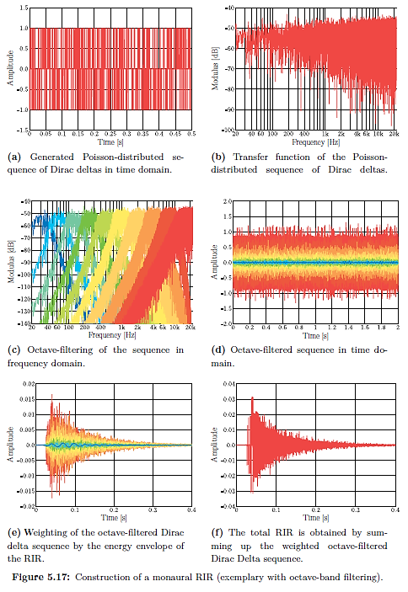

Figure 2: Overview about generation impulse response from energetically histograms

* 1. **Binaural Room Impulse Responses**

Generally we just need to apply the HRTF for each incoming wave, which is hitting the receiver. However, practically in real-time it is not efficient to proceed in this way. Although in the late reverberation tail the spatial information’s are not significant for the immersion.

To generate a binaural impulse response a few methods are available, one option is to make a spherical detector with discrete Directivity Groups. Then for each directivity group a histogram will be generated as shown in Figure 3. Before we are generating our impulse response as in Figure 2 we also need to include the special information. There are different approaches, for examples checking for each time slot, the energy distribution and applying the HRTF for this direction. Further details can be found in [2].

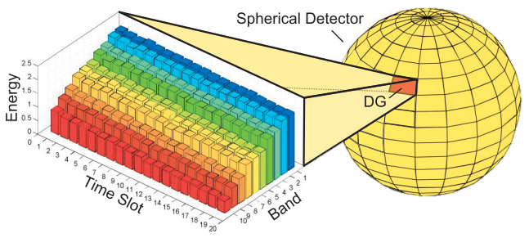,

Figure 3: Special detector for binaural impulse Response synthesis

* 1. **Interpolation**

In some applications e.g. sound insulation filters it can also be useful to interpolate the third octave band filters the get a full spectrum for the convolution in frequency domain. We will take the sound insulation filters as examples. These Filters are given as third octave band energy values from 50 Hz to 5k Hz, therefore they need to extrapolated before we interpolate them. Since the extrapolation is done we can interpolate them, e.g. Cubic Spline Interpolation, and than we need to add a phase to the magnitude spectrum. Here a liner phase is need to get I real filter in time domain. A Summary is in Figure 4.

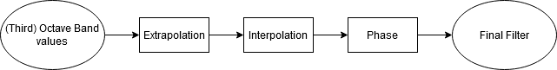

Figure 4: Filter diagram of using Interpolation for Frequency filter construction